**DESIGN AND IMPLEMENTATION OF A HOSTEL BOOKING SYSTEM :**

**NILE UNIVERSITY OF NIGERIA**

**BY**

**ONYEKPERE CHIBUEZE KINGSLEY**

**201212021**

**A PROJECT SUBMITTED TO THE DEPARTMENT OF SOFTWARE ENGINEERING AND INFORMATION TECHNOLOGY, FACULTY OF COMPUTING, NILE UNIVERSITY OF NIGERIA, IN PARTIAL FULFILMENT OF THE REQUIREMENTS FOR THE AWARD OF DEGREE OF BACHELOR OF SCIENCE IN SOFTWARE ENGINEERING, NILE UNIVERSITY OF NIGERIA**

**JUNE 2024**

NILE UNIVERSITY OF NIGERIA

**STATUS CONFIRMATION FOR BACHELOR’S PROJECT**

**HOSTEL BOOKING SYSTEM FOR NILE UNIVERSITY OF NIGERIA**

**ACADEMIC SESSION : 2023/2024**

I, **ONYEKPERE CHIBUEZE KINGSLEY** agree to allow this Degree’s Project to be kept at the Library under the following terms:

1. This Degree Project is the property of Nile University of Nigeria.
2. The library has the right to make copies for educational purposes only.
3. The library is allowed to make copies of this report for educational exchange between higher educational institutions.
4. ** Please Mark (√)

|  |  |  |
| --- | --- | --- |
| **k** | CONFIDENTIAL | (Contains information of high security or of great importance to Nigeria as STIPULATED under the OFFICIAL SECRET ACT ) |
| **k** | RESTRICTED | (Contains restricted information as determined by the Organization/institution where research was conducted) |
| **l** | FREE ACCESS |  |

|  |  |  |
| --- | --- | --- |
| _________________________ |  | Approved by,  __________________________ |
| (WRITER’S SIGNATURE) |  | (SUPERVISOR’S SIGNATURE) |
| Permanent Address :  House 117, Kenneth Ojo Crescent, Sahara 4 Estate, Lokogoma, Abuja, Nigeria  Date: ___________________ |  | Supervisor’s name:  Dr. Aliyu Suleiman  Date : 21st June, 2024 |

# **CERTIFICATION**

This is to certify that, the project titled “DESIGN AND IMPLEMENTATION OF A HOSTEL BOOKING SYSTEM FOR NILE UNIVERSITY OF NIGERIA” by ONYEKPERE CHIBUEZE KINGSLEY 201212021 has been approved by the undersigned for meeting the requirements for the award of Bachelor of Science in Software Engineering (BSc. Hons in Software Engineering by the department of Software Engineering, Nile University of Nigeria, Abuja.

……………………………….

Dr. Mohammad Aliyu Suleiman

PROJECT SUPERVISOR

……………………………………

Dr. Ibrahim Anka Salihu

HOD SOFTWARE ENGINEERING AND INFORMATION TECHNOLOGY

…………………………………….

Prof. Musa Muhammad

DEAN (FNAS)

..........................................................

EXTERNAL EXAMINER

# **DECLARATION**

I hereby declare that the work in this project is my own except for quotations and summaries which have been duly acknowledged.

Student : …………………………………………………….

Date : …………………………………………………….

Supervisor : …………………………………………………….

DR. MOHAMMED ALIYU SULEIMAN

# **DEDICATION**

I dedicate this study to God, my supportive family, and all the lecturers who supported me throughout my time at Nile university of Nigeria, most especially my supervisor, Dr. Aliyu Mohammad Suleiman, who guided me through this project, and Dr. Umar Adam Ibrahim, who has helped me over the years to become a better software engineer.

# **ACKNOWLEDGEMENT**

I would like to express gratitude to God for his direction and guidance through this journey through university. I would also like to thank my family for supporting me and being with me throughout. Finally, I would like to thank my project supervisor, Dr. Mohammed Aliyu Suleiman, whose guidance helped me complete this project.

# **ABSTRACT**

The hostel is an important component of secondary and tertiary institutions around worldwide. Hostels provide **low-cost housing and a social atmosphere**, with students sharing common areas such as kitchens, lounges, and bathrooms. Hostels offer a platform for people to make new friends worldwide and learn about different cultures. Using technology, some processes involving the hostel reservation have been automated and made more efficient. However, hostel reservation still remains an issue. The hostel reservation process is a tedious one and the current system is inefficient and is not very transparent. The application of technology to the process of hostel reservation will go a long way in making the process more efficient and more effective. This project proposes a web-based hostel reservation system which will implement the Genetics Algorithm to optimize the hostel reservation process.

# **CHAPTER ONE**

INTRODUCTION

*Hostel reservation is important to every institution. The issue of creating an optimal system for hostel reservation is a very critical one, and there are specific constraints and rules applied to it in every institution. This chapter discusses the problems with the current hostel reservation system at Nile University of Nigeria, and introduces a solution that aims to solve this problem.*

1. **Background of the Study**

Effective hostel reservation is a very important component that supports the smooth accommodation of students. A well-organized hostel reservation system makes it easy and efficient to make hostel reservations and track hostel information relating to on-campus activities.

An extensive analysis of a wide range of factors and restrictions is required to develop a complete and useful hostel reservation system. These include essential components including the availability of suitable rooms, the assignment of rooms to students, and the avoidance of any assigning a room to too many students at a time.

Today institutions have tools used for hostel reservations. The tools however, lack a system that allows students to know their room beforehand. This leads to students staying in rooms where they barely manage to get along with their roommates. As a result, students may not get the best possible experience while staying on-campus.

Students in universities do not know which rooms they are lodging in until they get to the school which makes their reception very disorganized. Students are assigned rooms on the day they resume a new semester, and this assignment is often haphazard and disorganized.

For assignment of refectory tickets, the current system still requires human involvement in giving out the tickets which wastes a lot of paper and often results in long and disorganized queues. These queues are a result of the hostel supervisors handing out tickets manually which is very inefficient

The implementation of a digital Hostel Reservation System (HRS) appears as a promising approach to address these challenges and improve the accuracy and efficiency of the hostel reservation process at Nile University of Nigeria. The Hostel Reservation System transforms how hostel reservation is carried out, by utilizing cutting-edge algorithms and computing power. By automating the process, the HRS makes sure that hostels are assigned efficiently while sticking to the established constraints and considerations at the school. The assignment process is greatly simplified by this automation, which also lessens the need for extensive manual modifications.

This Hostel Reservation System (HRS) at Nile University in Nigeria has the potential to completely alter the way that hostel reservations are made, resolving many of the issues with the current system. The HRS equips the school to assign rooms to students in an efficient, effective, and constraint-compliant by utilizing the power of algorithms and computational intelligence.

* 1. **Statement of the Problem**

The school's current system for hostel reservation has serious problems. Students are assigned rooms manually and at random. This ultimately reduces familiarity with roommates and increases the potential for conflicts. The process is not transparent as students who apply for hostel do not know the exact room they are going to lodge in until they come to the hostel reception. Ultimately a student could get frustrated or misdirected when trying to find a suitable room where they could lodge in.

For the refectory system the use of tickets is paper-intensive which is not sustainable and harmful to his environment. Additionally, the system is vulnerable to unnoticed constraint violations because of its reliance on manual labor. Supervisors could misplace the tickets which could lead to a lot of problems down the road. Also, the process of manually assigning tickets to each students at the refectory is very disorganized because the line for students to get a ticket is different from the one they would use to get their meals.

In a lot of institutions, on campus students do not have a system by which they could voice out their complaints to the hostel management. This could lead to unsettled grievances and lower student satisfaction.

* 1. **Aim and Objectives**

The aim of this study is to improve the efficiency of the hostel reservation process at the school by developing a web-based Hostel Reservation System for the school.

The objectives of this research work are:

I. To implement a reservation system that allows students book a room with their preferred roommates

II. To implement a refectory ticket assignment system

III. To test and evaluate the implemented systems

* 1. **Significance of the Study**

The proposed Hostel Reservation System (HRS), which is specifically designed for Nile University of Nigeria and takes into account the institution's unique constraints, will significantly increase the efficiency of the Hostel Reservation process by addressing the flaws of the current system. The automation of refectory ticket assignment will make the dining hall more organized during meals. It also reduces the need to print out refectory tickets which reduces paper wastage and its effects on the environment.

* 1. **Justification of the Study**

The current system of hostel reservation at the school is not efficient, and the consequences of its inefficiency have been felt by the students; thus, there is a need for a new system that solves all the problems of hostel reservation. This will enable the system to create a system that takes into account all the important constraints that are considered when dealing with hostel reservation at the university.

* 1. **Scope and Limitation of the Study**

The scope of this study is to develop a Hostel Reservation System (HRS) for Nile University of Nigeria. It will be a web-based system that automates the process of hostel assignment and allows students to book hostels before the semester begins. The system will also make sure that refectory tickets are handed out thirty minutes before a meal commences.

The limitations of the proposed system are:

1. The system only works for students who have paid for accommodation so off-campus students will not have access to the system.

2. The system is web based, meaning it can only be accessed by users with an internet connection.

3. Requires integration into school system to know who has paid for accommodation

* 1. **Definition of Operational Terms**

1 **Hostel**: A hostel is a building dedicated to housing on-campus students to provide shelter, feeding and other basic needs.

2 **Algorithm**: This is a step-by-step procedure for solving a particular problem in a finite amount of time.

3 **Database**: A centralized repository of structured data, designed to support efficient data storage, retrieval and maintenance.

4 **Hostel Reservation**: The process by which a student is assigned to a room

5 **Hostel Reservation System (HRS)**: A web-based system that will automate the process of hostel reservation by using an algorithm to assign a room to a particular group of students without clashes and constraint violations. It would also allow students to reserve refectory tickets and voice complaints about the hostel.

6. **Refectory**: A dedicated room or building where students converge to eat meals provided by the hostel during established meal times

# **CHAPTER TWO**

LITERATURE REVIEW

*Literature review is important in any academic research, as it provides examination of existing works and knowledge on the topic at hand. This chapter discusses some of the works related to automated hostel reservation.*

1. **General Information**

The process of getting a room to stay in a university’s hostel is known as hostel reservation. It could be disorganized or very efficient, depending on the system put in place. The hostel reservation process is particularly tailor-made to each and institution because each institution has its set of policies and constraints that must be taken into account.

Unfortunately, manual hostel reservation procedures are still widely employed in many universities. The students may not know the exact room they are meant to lodge into which causes a lot of confusion during resumption. The time and effort required for this manual technique appears to be unproductive because they may be better spent on more important duties.

Some universities use Commercial Off-The-Shelf (COTS) software to enable students to pay for hostel accommodation. These systems, however, usually lack the flexibility needed to accommodate the unique constraints of various institutions. As a result, institutions, including the subject of this study, are forced to use manual techniques follow-up with the hostel allocation process after the payment has been made. This defeats the point of the automation’s intended goal that is to be provided by the system.

Researchers have put forward the idea of an automated hostel reservation systems to streamline the process of allocating hostel rooms by leveraging the power of computing devices. Several factors such as creating user-friendly interfaces, securely managing user-data and addressing other important difficulties have been highlighted in past research, a variety of algorithms have been investigated to optimize the process of hostel reservation.

* 1. **Related Works**

A study by Jazira Anuar (2013) analyzed four hotels that each had an online reservation system to ensure that their room allocation is seamless. The researchers were able to determine the core benefits (same benefits offered by all hotels), partially common benefits (part of benefits that are same among hotels studied) and individual benefits (the unique

benefit provided by the hotels). The results of the study showed that each hotel is at its very best when they offer unique benefits in an attempt to differentiate themselves from their competitors even though they all shared four (4) same core benefits which included room reservation, check-in, check-out and cancellation of order.

Another study by Bedard (2020) explores the two main back-end systems used in hostel-reservation which are Central Reservations System (CRS) and Property Management System (PMS). Bedard stated that a CRS acts as a medium to update Availability, Rates and Inventory (ARI) between the PMS to hotel website or third party channel while a PMS is used to manage all of the needed management such as housekeeping, point of sale (POS), check-in or check-out, and other management tasks.

Another study from Delta State University by Akauze (2016) posits that hotel management systems are still rigid in accommodating reservations with breaks between check-ins, check-outs, re-check-in and re-check-out. This necessitates the development of a model for integrating a flexible reservation system that will allow for multiple booking capability in a hotel management system.

A study by Win, Myint Myint (2022) states that a computerized reservation system of hotel is to make transaction to be accurate and fast, to keep the client's record (list) systematically and effectively. Computerized reservations system can be handled and it finds that making a booking just takes a few minutes. Any system that does not provide this convenience of making a transaction that sorts out room allocation and presenting information could lose out on potential customers.

A study at the article titled “The Determinants of Online Hotel Reservations among University Staffs” by Bakar (2008), states that with traditional reservation method, customers can easily change their particulars while talking to the hotel staff. They can effortlessly make any changes. However, when customers utilize hotel online reservation, such alterations are entirely the customers’ responsibility. In the case of airline online reservation, any changes to prior reservations will be charged and there will be adjustments to the flight tickets in addition to availability. Consumers concern in this matter might have a “halo effect” on hotel online reservation.

In another study by Ajang (2023) it was proposed that hotel management systems encourage and reward individual and unified effort and achievement, provide training and personal development opportunities and create a working environment in which staff can feel a real scene of job involvement.

In a study by Janne (2006) a hotel management system that can be used online was developed. This system allows the guests to do their booking online by them self. Some of task that the system can do are providing a query for arriving date and the length of staying, providing the number of rooms, view all available rooms and provides user the ability to choose one or more of them, recording the number of on rooms, view all available rooms and provides the user the ability to choose one or more of them, recording kind of guests and how many going to be in the single room, providing the cost of booking, asking the users if they want additional service; such as, dinner or breakfast, storing the guests detail; like, name, address and telephone, asking the user for confirmation, final confirmation views with the detail of booking and the guests can review or cancel the booking.

In a paper titled “Development of an Automated Hostel Facility Management System” by Kola Ayanlowo (2014), researchers state that the manual method of managing and administering hostels in institutions is obviously not effective as it is attributed to the following challenges:

* Difficulties in record management - data redundancy, difficulty in data update; difficulty in data recovery; difficulties in generating information about those students who had left the hostel, vulnerability to manipulations/human error;
* Difficulty in tracking the history of a facility – a room or chalet or building;
* Registration for hostel allocation is done manually, thus over time, handling of the paper files becomes cumbersome and untidy as the population of student increases;
* The whole exercise is time-consuming and a waste of human and material resources.

The study proposed a system that attempts to improve institutions’ hostel services for stakeholders - administrator, management and students of the hostel. It automates the administrative processes and reduces the stress associated with searching for information on a student/a facility in a bundle of registers. It is specially designed to centrally allocate and manage accommodation spaces in a typical student’s hostel.

A study titled “Hostel Management System” by Luitel (2022) states that There are similar patterns of modules used in many hostels and dorms worldwide. Hostel Management System Software developed and used currently has mainly six modules which include reservation, accounts, assigning chores inventory, enquiry, visitors tracking modules. The system implements all six functionality using a web app built with Java and MySQL.

The use of Genetics Algorithm is explored in a study by Rayner (2020) at University Malaysia Sabah, Jalan. The study states that Automated scheduling is usually executed using a scheduling algorithm to generate a sequence of actions in order to achieve certain objectives. The results of testing the proposed system were successful, and the study concludes that the Genetics Algorithm is capable of allocating hostel rooms without any conflicts.

In another study titled “Hostel Management System Using Image Recognition” by Mensah, (2022) it was seen that the Babcock University Hostel Management System was used as a case study. The Babcock University hostel management system is primarily based on the University Management Information System, UMIS which Babcock University uses as its online

platform for semester registration, result checking, online examination, hostel registration, and much more. To select a hall of residence for a new semester at Babcock University,

you log on to umis.babcock.edu.ng, put in your students’ credentials, and then select login. Student registration begins by selecting a meal type, worship center, and then hall of

residence. For this segment, the study makes use of a male undergraduate student of Babcock University as a case study to adequately illustrate the registration process. There are seven available halls of residence for the male students namely; Gideon Troopers Hall, Winslow Hall, Bethel Splendor Hall, Samuel Akande Hall, Nelson Mandela Hall, Neil

Wilson Hall, and Welch Hall. These halls are classified into two classes based on cost and comfort, namely; Premium halls and Classic halls. The classic halls are the more

expensive and comfortable halls while the premium halls are less expensive, and therefore less comfortable than the classic halls. To register in a certain hall, you select your preferred hall of residence under the “Hall of residence” section during registration. If your preferred hall of residence is fully booked, an error message appears upon selection of that hall.

Once your registration is complete and financial approval has been given, a receipt would be generated for the now-registered student and he is to print that receipt and present it

upon the day of resumption. On arrival on the school campus, the receipt is presented to the porter of the hall of residence and that is where the physical registration begins. The

physical registration includes; retrieving your file from your previous hall of residence (in the event in which a student switches halls), and then you are allocated a room by the hall

administrator.

In another study on DESIGN AND IMPLEMENTATION OF ONLINE HOSTEL MANAGEMENT SYSTEM (EMMANUEL, 2015), the system at College of Agric Lafia was reviewed. The study explains that the current hostel allocation and management system at College of Agriculture Lafia is done manually; during application, the student’s first of all go to the student’s affairs unit to verify hostel availability, if available the student is giving a BED-SPACE REQUISITION/ALLOCATION FORM. The student will have to fill the form, take the form to his/her head of department for verification, the HOD will check to find out if the student is eligible and belongs to the category of student’s entitled to hostel accommodation. If the student is qualified, the HOD will approve by signing the form. The student will now go to the bank and pay the accommodation fee to the college account, the form is giving free but the accommodation fee is ₦90 and is paid alongside with the school fees, while the maintenance fee is ₦2500 is also paid to the school account but is done separately. After the payment, the student proceeds to the bursary unit for exchange of teller to receipt, the student then goes to the student’s affairs unit with the form, the bank teller and the receipts. The student’s affairs officer keeps the record of the bank details; the student affairs officer who is also the hostel coordinator will verify the hostel availability and then allocate the student if available. The allocation of rooms to students is done on the basis of first come first serve, the category of students entitled to hostel accommodation includes: Pre ND, ND2, pre HND, HND2. College of agriculture lafia has a total number of 13 hostels, 8boys hostels and 5girls hostels. The hostels are named as follows: boy’s hostels (Lafia Hall, Wamba Hall, Keana Hall, Awe Hall, Toto Hall, Keffi Hall, Doma Hall, Nasarawa Hall,). Girls Hostels (Nasarawa Eggon, Akwanga, Obi, Kokona, and Karu Hall). The room capacity for boy’s hostel is 5per room and is based on bed-space, whereas for girls vary, some hostels are having capacity of 5, 4, 3, and 2. The method of storage of student’s data is done using hard-cover notes and is done based on hostels i.e. each hostel has a hard cover notebook for its record keeping. Some of the challenges faced by the college management and students include: limited hostel accommodation, inefficient storage method, slow retrieval of information increased student’s population each session.

* 1. **Summary of the Review**

Table 2.1: *Summary of Literature Review*

|  |  |  |
| --- | --- | --- |
| TITLE | **SUMMARY** | **LITERATURE GAP** |
| Jazira Anuar, (2013)  Smartphones Application Adoption Benefits Using Mobile Hotel,  *Procedia - Social and Behavioral Sciences* | This study states that each hotel is at its very best when they offer unique benefits in an attempt to differentiate themselves from their competitors even though they all shared four (4) same core benefits which included room reservation, check-in, check-out and cancellation of order. | * No technical implementation of hotel reservation system was suggested |
| Bedard, M. (2020)  New Trends in CRS and PMS  *Amadeus Journal* | This study explores the two main back-end systems used in hostel-reservation which are Central Reservations System (CRS) and Property Management System (PMS). | * No consideration of course sections. * No technical implementation of hotel reservation system was suggested |
| Akauze, M.1 (2016)  Enhanced Hotel Management Information System for Multiple Reservation Booking  *Delta State University* | This study suggests the development of a model for integrating a flexible reservation system that will allow for multiple booking capability in a hotel management system. | * No consideration of course sections. |
| Win, Myint Myint (2022).    Computerized Reservation System For Taunggyi Hotel  *Computer University Taunggyi.* | This study stated that the Computerized reservation system of hotel is to make transaction to be accurate and fast, to keep the client's record (list) systematically and effectively. Computerized reservations system can be handled and it finds that making a booking just takes a few minutes. | * No consideration of course sections. |
| Bakar (2008).  The Determinants of Online Hotel Reservations among University Staffs.  *Ibima Publishing.* | This paper states that with traditional reservation method, customers can easily change their particulars while talking to the hotel staff. They can effortlessly make any changes. | * No consideration of course sections. |
| Elizabeth Betty Ajang (2023).  Hotel Reservation System  *Toaz Info* | This study proposes that hotel management systems encourage and reward individual and unified effort and achievement, provide training and personal development opportunities and create a working environment in which staff can feel a real scene of job involvement | * No consideration of course sections. |
| Janne (2020).  Hotel Manaement System  *Liacs.* | This study proposes a system allows the guests to do their booking online by them self. Some of task that the system can do are providing a query for arriving date and the length of staying, providing the number of rooms, view all available rooms and provides user the ability to choose one or more of them, recording the number of on rooms, view all available rooms | * No consideration of course sections. |
| Kola Ayanlowo, O. Shoewu (2014).  Development of an Automated Hostel Facility Management System.  *Journal of Science and Engineering* | Researchers state that the manual method of managing and administering hostels in institutions is obviously not effective as it is attributed to the following challenges:  • Difficulties in record management  • Difficulty in tracking the history of a facility  • Registration for hostel allocation is done manually  • The whole exercise is time-consuming and a waste of human and material resources. | * No consideration of course sections. |
| Mensah, Yaw A. (2022).  Engineering and Technology Journal  *Hostel Management System Using Image Recognition* | The Babcock University hostel management system is primarily based on the University Management Information System, UMIS which Babcock University uses as its online  platform for semester registration, result checking, online examination, hostel registration, and much more. | * No consideration of course sections. |
| EMMANUEL, AYAKA AKOLO (2015)  DESIGN AND IMPLEMENTATION OF ONLINE HOSTEL MANAGEMENT SYSTEM  *International Journal of Applied Research.* | The system at College of Agric Lafia was reviewed. The study explains that the current hostel allocation  and management system at College of Agriculture Lafia is done manually; during application, the student’s first of  all go to the student’s affairs unit to verify hostel availability, if available the student is giving a BED-SPACE REQUISITION/ALLOCATION FORM.  The method of storage of student’s data is done using hard-cover notes and is done based on hostels i.e. each hostel has a hard cover notebook for its record keeping. Some of the challenges faced by the college management and students include: limited hostel accommodation, inefficient storage method, slow retrieval of information increased student’s population each session. | * No consideration of course sections. |

# **CHAPTER THREE**

SYSTEM ANALYSIS AND DESIGN

*Prior to the software construction process, it is important to do system analysis, and design the system to be developed. This chapter discusses the analysis and design of the hostel reservation system.*

1. **System Analysis**
   * 1. **Analysis of the Existing System**

The existing system of hostel reservation at Nile University of Nigeria is inefficient and the hostel management has to cope with a manual process, where the hostel supervisors assign rooms to the students on the day of resumption.

This is usually a tedious and disorganized process, as students may have to wait on a long line at the reception to get assigned to a room. It also creates a system where students might be placed with roommates who are in different departments/levels which could stifle the chances of them to have common grounds for academic and social interaction.

### **Limitation of the Existing System**

The limitations of the existing system include the following:

* + 1. Opaque hostel process leaves applicants unaware of assigned rooms at check in
    2. Ticket-based refectory system is unsustainable and harmful to the environment
    3. With manual ticket assignment, separate lines tickets and meals creates confusion

### **Justification for the New System**

The frustration stemming from manual room assignment, opaque hostel processes, unsustainable ticket-based refectory systems, and the confusion caused by separate lines for tickets and meals highlights the pressing need for an innovative solution. A Hostel Reservation System, offering advance room bookings, roommate selection, and pre-meal ticket reservations, addresses these issues. This streamlined approach not only enhances efficiency but also empowers users with choices, ensuring a more transparent, sustainable, and user-friendly experience.

### **Description of the New System**

The new system is a hostel reservation system, which will allow students to reserve dorm rooms ahead of resumption with the option of staying in the same room as their friends’/course mates. It will also facilitate the provision of digital tickets that can be used to get meals during meal times.

## **Design of the Proposed System**

### **Data Model**

* + - 1. User Model: This model captures information about the system's registered users. It includes fields such as name, email address, password, and gender.
      2. HostelPlan Model: The HostelPlan model encompasses various plans related to hostel accommodations, accommodating different room capacities. It stores details such as the plan name, room capacity, and any other relevant plan-specific information.
      3. HostelBuilding Model: The HostelBuilding model represents the buildings within the hostel facility. It includes details like building name and may also incorporate information about the number of floors within each building.
      4. Floor Model: This model is associated with each floor within a hostel building. It includes information such as the floor number and may establish relationships with the Room model to denote the rooms present on that floor.
      5. Room Model: The Room model captures details of individual rooms within the hostel. It includes information like room number, building, and capacity.
      6. Ticket Model: The Ticket model is responsible for recording information related to hostel meal tickets. It includes fields such as email (linked to the user), details of meals consumed, and the type of meal (e.g., breakfast, lunch). This model facilitates tracking and managing the meal usage of each resident.

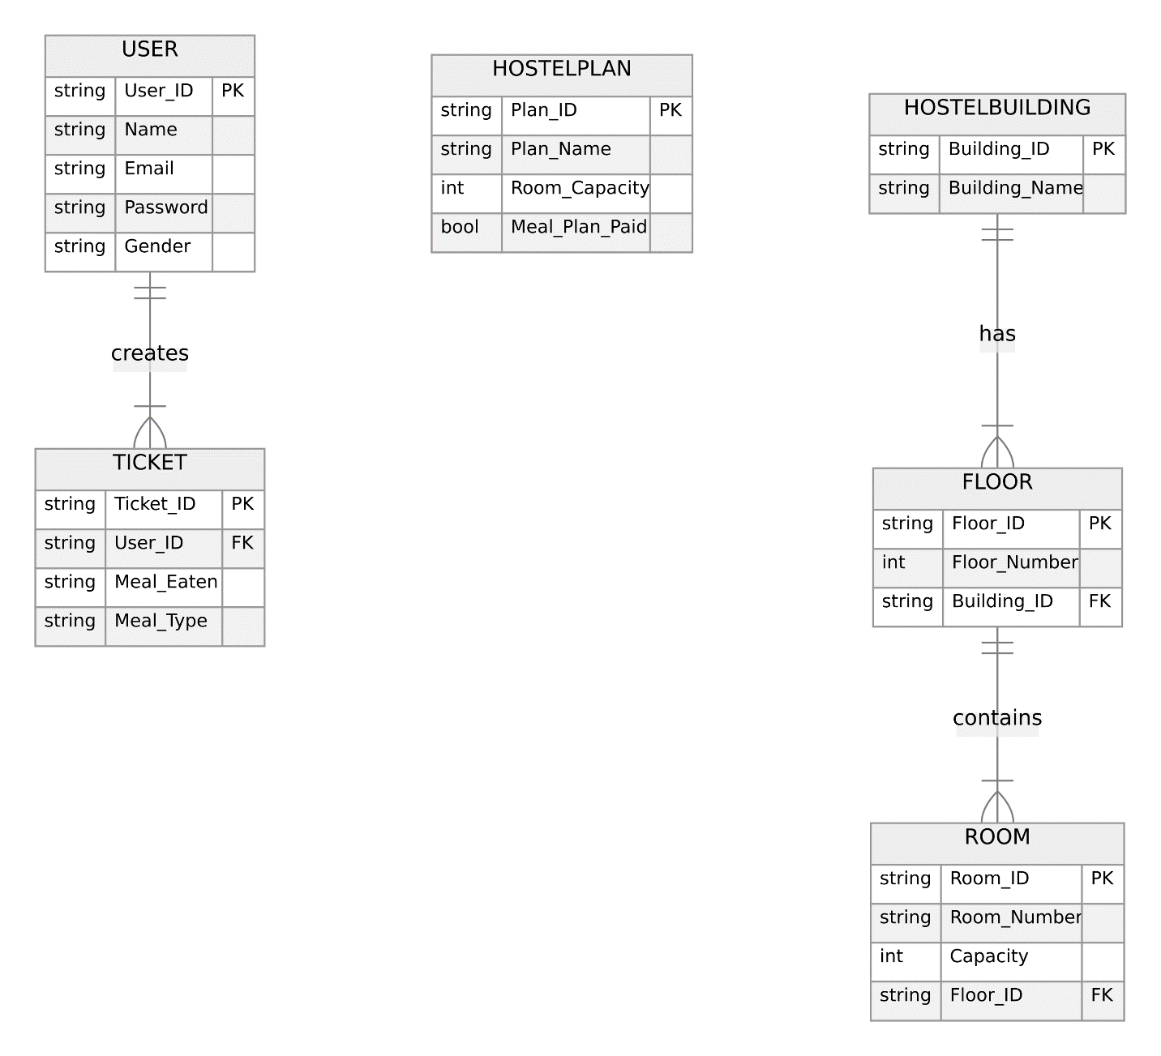

Figure 1 Entity Relationship Diagram For Hostel Reservation System

### **Functional Requirement (*Use Case Diagram*)**

The functions available to the users of the system are:

1. Student Login/Register/Logout:
   1. Login:
   2. The system shall provide a secure login mechanism for students.
   3. Students shall be required to enter their valid email and password to access the system.
   4. The system shall validate user credentials before granting access.

1.2 Register:

* 1. New users shall have the option to register by providing their name, email, password, and gender.
  2. The system shall validate and store the registration information securely.

1.3 Logout:

* 1. The system shall provide a logout option for students to securely end their session.
  2. Upon logout, the system shall redirect the user to the login page.

1. Book Meal Ticket Depending on Meal Plan Has Been Paid:

2.1 Meal Ticket Booking:

* 1. The system shall display an option for students to book meal tickets.
  2. Before booking, the system shall check if the meal plan has been paid.

1. Hostel Plan Reservation Depending on Room Capacity and If Meal Plan Has Been Paid:

3.1 Hostel Plan Reservation:

* 1. The system shall present an option for students to reserve hostel plans.
  2. Before allowing reservation, the system shall check the room availability
  3. The administrator shall approve all room reservation requests

1. Drop Room Reservation:

4.1 Room Reservation Drop:

* 1. The system shall provide an option for students to drop their room reservations.
  2. Upon selecting this option, the system shall cancel the reservation.

4.2 Confirmation:

* 1. The system shall display a confirmation message to the student after successfully dropping the reservation.

1. View Room Reservation:

5.1 Access Room Reservation:

* 1. The system shall provide a section for students to view details of their current room reservation.
  2. If no reservation exists, the system shall provide a message indicating the absence of reservations.

1. View Meal Ticket:

6.1 Access Meal Ticket:

* 1. The system shall provide a section for students to view details of their current meal ticket.
  2. If no meal ticket is booked, the system shall provide a message indicating the absence of bookings.
  3. The Refectory server shall view the meal ticket to confirm a student’s participation in the meal

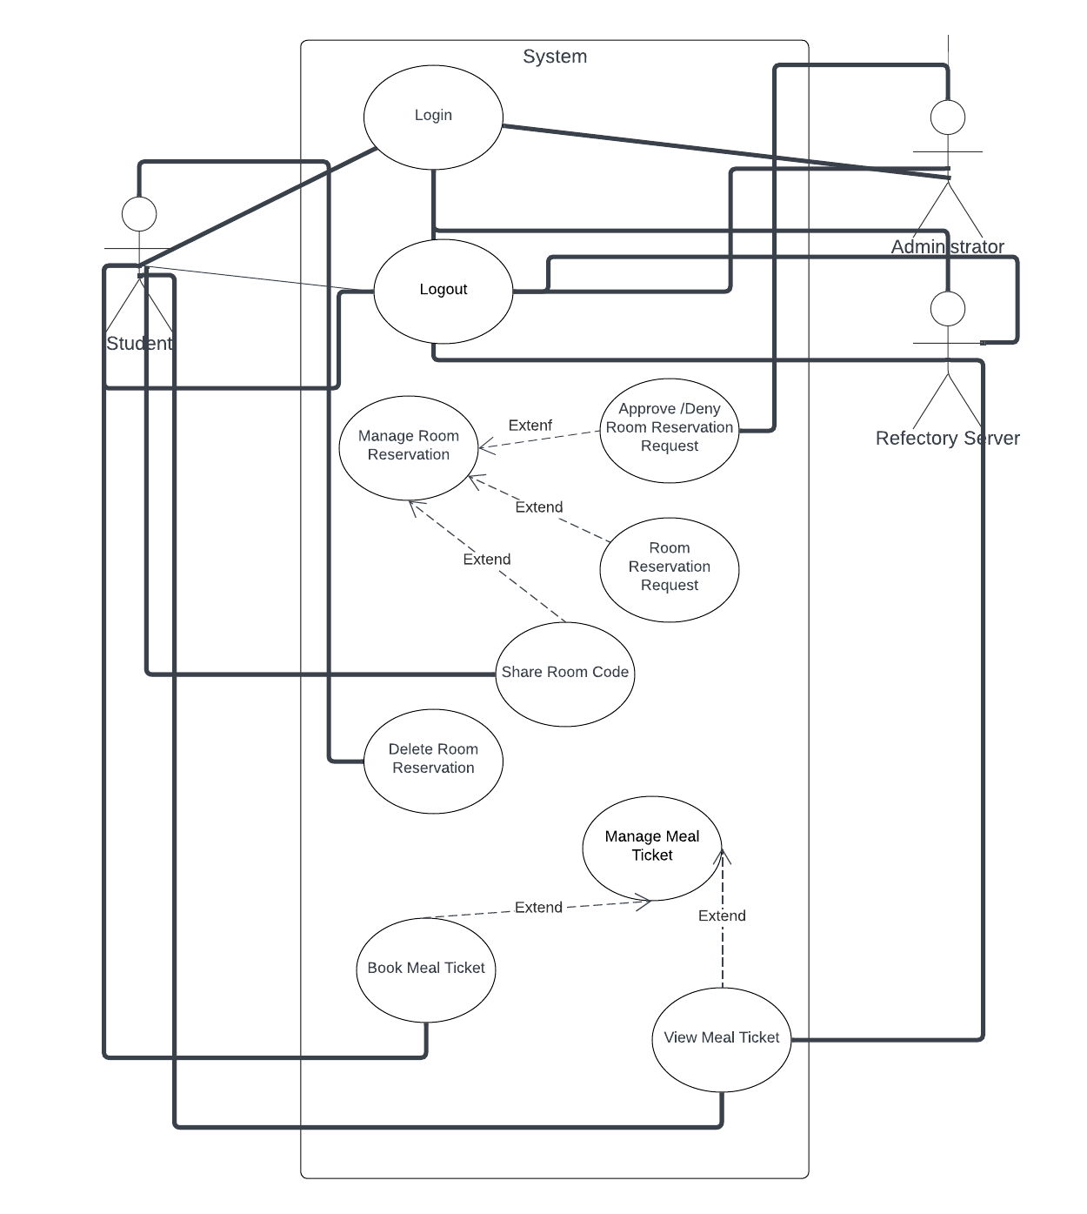

Extend

Extend

Figure 2 Use Case Diagram For Hostel Reservation System

### **System Architecture *(Deployment Diagram)***

The system will be deployed to Firebase on Google Cloud.

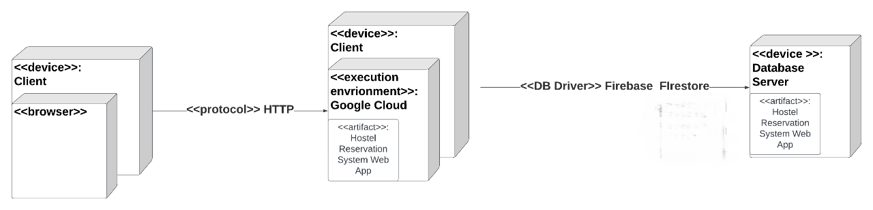

Figure 3 Deployment Diagram for Hostel Reservation System

### **3.2.4** **Software Structure *(Class Diagram)***

The classes in the system include:

1. **User:**
   1. Attributes: username, password, email, firstName, lastName, gender.
   2. Represents the registered users of the system.
2. **Student:**
   1. Attributes: Inherits from User and adds studentID, program, level.
   2. Represents students using the system.
3. **Administrator:**
   1. Attributes: Inherits from User and adds adminID, department.
   2. Represents administrators in the system.
4. **RefectoryServer:**
   1. Attributes: Inherits from User and adds serverID.
   2. Represents servers in the refectory.
5. **HostelPlan:**
   1. Attributes: planName, roomCapacity, planDetails.
   2. Represents various plans related to hostel accommodations.
6. **MealTicket:**
   1. Attributes: ticketID, email (linked to the user), mealsConsumed, mealType.
   2. Represents records related to hostel meal tickets.
7. **HostelBuilding:**
   1. Attributes: buildingName.
   2. Represents buildings within the hostel facility.
8. **Floor:**
   1. Attributes: floorNumber.
   2. Represents individual floors within a hostel building.
9. **Room:**
   1. Attributes: roomNumber, building, capacity, isLaboratory.
   2. Represents individual rooms within the hostel.

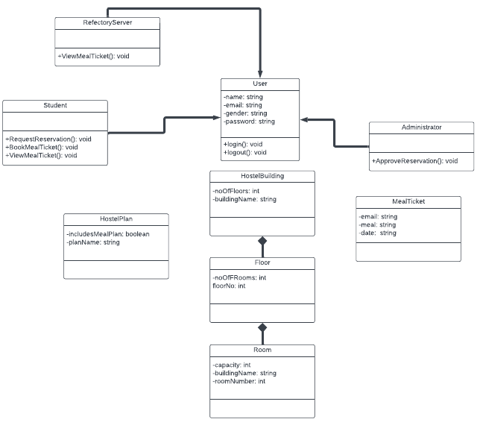

### **Workflow of Use Cases (*Activity Diagram*)**

Eligible users (students, administrators and refectory servers) can login to the system. If the wrong credentials are entered, the system returns an appropriate error message. After successful login, the system determines if a user is a super administrator or faculty as administrators and refectory servers each have a unique account.

Student can request hostel reservation, drop hostel reservation that has been approved and book meal ticket (if hostel accommodation request with meal ticket has been approved) and view the meal ticket, administrator has the choice to approve a hostel accommodation request based on certain constraints and refectory server can view the meal ticket to confirm if the student has paid for the meal plan before serving food to the student.

